Finance functions

This is a short overview for some of the finance functions in SpeedAdmin.

Overview 2
Process (checklist) 3
1. Setting up payment system 4
a. Create payment rate 4
b. Create Tuition fee + added rates 4
c. Setup discount (Sibling, Multiple etc.) 4
d. Add fees to the course/coursetype 4
e. Update all payments 4
School billing 4
2. Check for “Payments not approved” 5
Fields and features: 5
3. Add fixed discounts 7
Reimbursement 7
4. Do checks 8
5. Draft – Invoice – Post orders 8
Direct Billing 10
6. Check and chase from Accounting 11
Accounting page Overview 11
Add payments manually 12
Direct debit corrections 14
School billing 15
7. Amendments can be done on payers profile (Reset) 15

Overview
The finance setup and functions is on Settings – Payments:
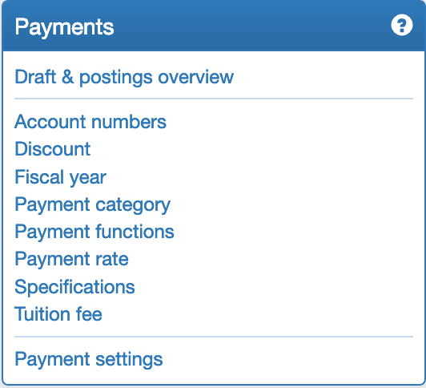

And/or in the top Meny Finance:
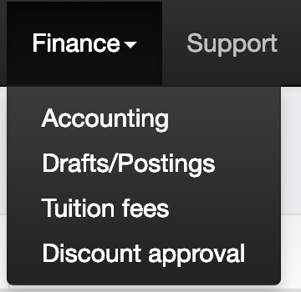

Finally the payment for each payer (Student/Guardian/School/user) can be seen and edited on their profile on the payment tab:
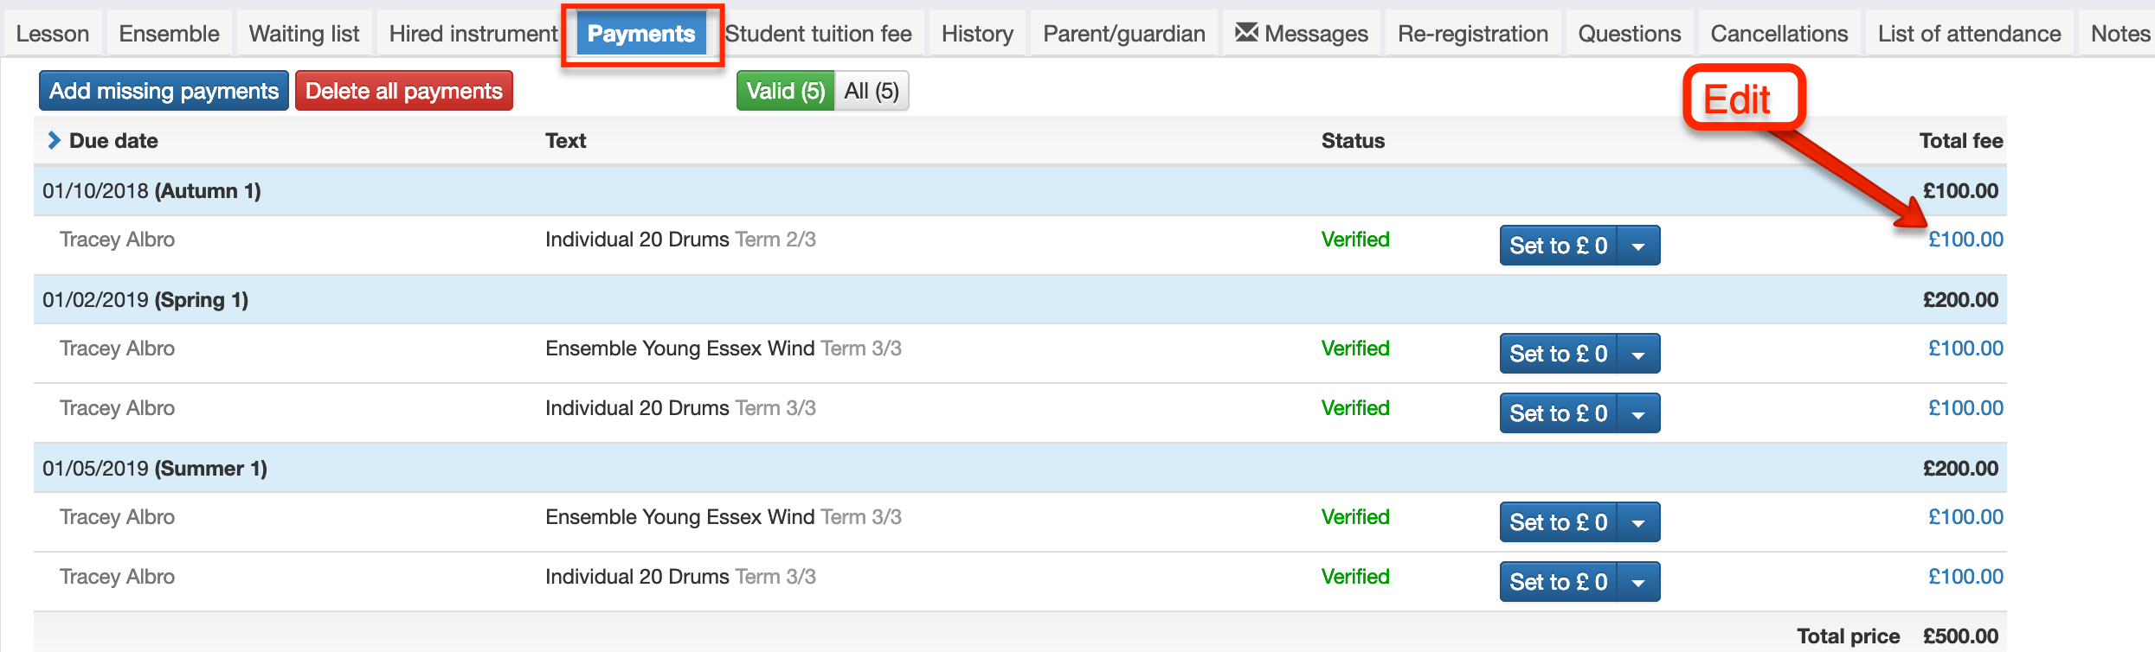

Process (checklist)

- Setting up payment system:
- Check for not approved payments (Notification tray) https://speedwareaps.zendesk.com/hc/da/articles/115003092845-Payments-not-approved
- Add fixed discounts
- Do checks (if necessary) and do specific changes if needed on Payer profile.
- Draft payment
- Send out invoice (or from Accounting after posting)
- Check and chase from Accounting
- Amendments/Change payer/Payout

Setting up payment system
  - Create payment rate (Settings –> Payment rate)
  - Create Tuition fee + added rates (Settings -> Tuition Fee)
  - Setup discount (Sibling, Multiple etc.) (Settings –> Discount)
  - Add fees to the course/coursetype (Settings -> Coursetype or Course)
  - Update all payments (Settings –> Payment functions)

When the payment system have been set up you will for next academic year be able to copy over the rates to next academic year when it has been created.
  - Choose next academic year in the top menu
  - Copy rates from previous year Settings –> Rates
  - Copy rates into all active tuition fees Settings –> Tuition fee
  - Update all payments (Settings – Payment functions)

School billing

For now adding school invoices is done 100% manually according to this Step-by-step guide:

- Setup a tuition fee with inactive rates and amount can be zero:
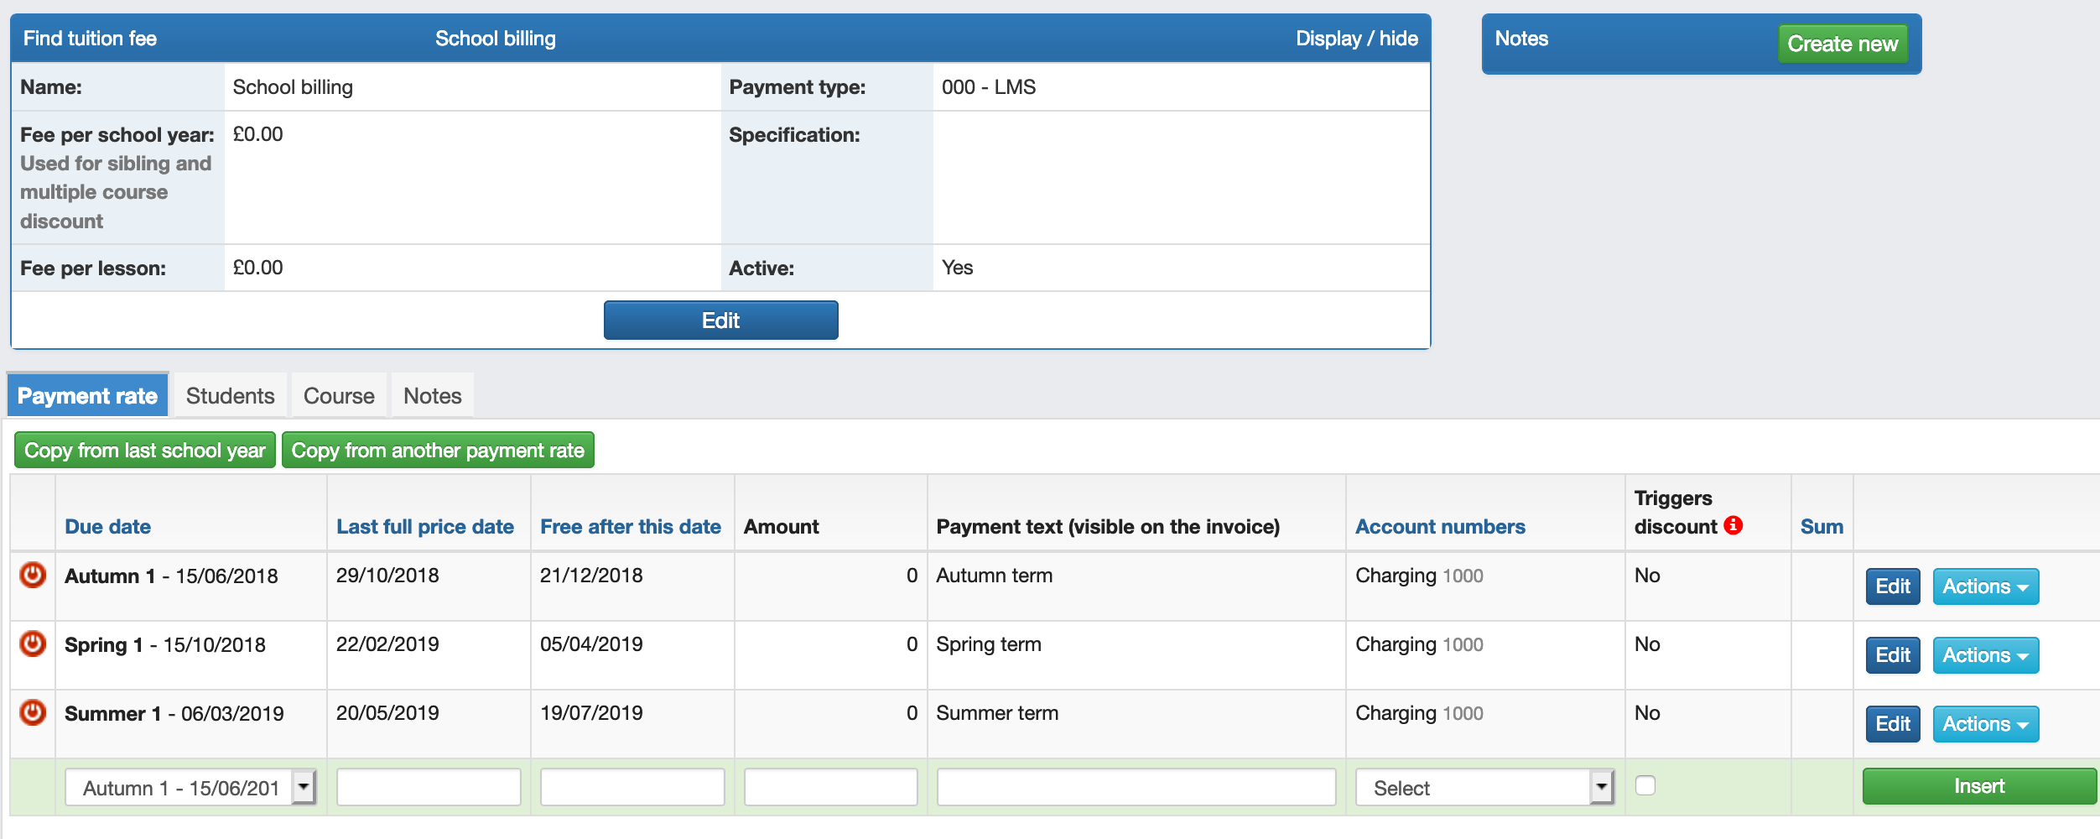
- Search the school you wish to add a payment for by using the “Super-searcher”, or Search -> School
- On Schools profile choose the tab “Orders”
- Add order line:

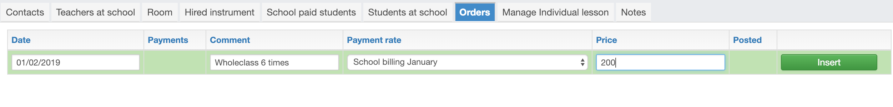
Date: Will always be controlled by the payment rate you choose
Comment: add info for what the order is for
Payment rate: Choose a tuition fee set up for school billing, and the specific rate for when you want it to be due.
Price: Add the price for this payment

- Invoice will now be posted and send of along with the student invoices if you wish. Invoices can also be downloaded from the Account page – see “Accounting” below.

Check for “Payments not approved”

In the notification tray in the top menu, you will find the overview of “Payments not approved”.:
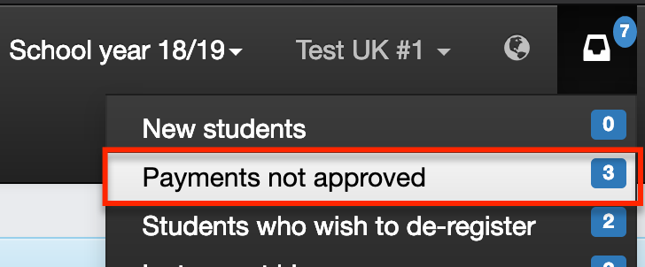

On this list you will find all payments that the system can’t automatically verify, as the students start or end a course or instrument hire within the range of dates between "Last full price date" and "Free after this date".
Check Settings -> Tuition fee to edit the range of dates for the Tuition fees:

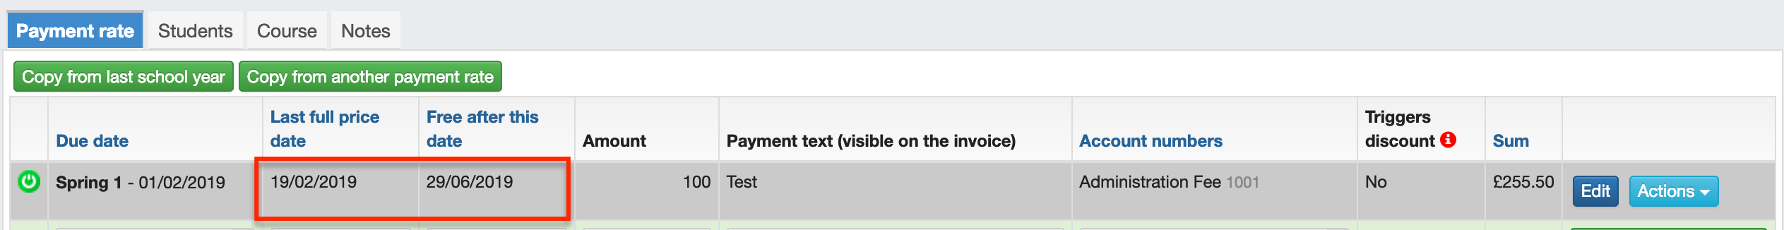
To put in other words, payments must be approved whenever students start the course mid-term or de-register before the end of term.

IMPORTANT! These payments must be approved before they can be added to an draft and posted (invoiced)

Fields and features:

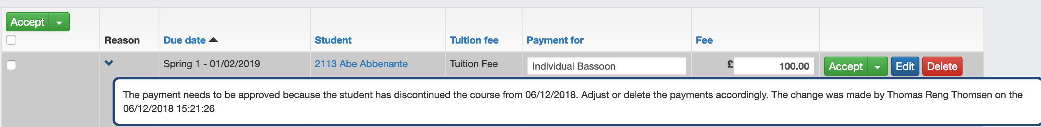

“Reason” column: Press “>” to see the reason for the payment not being approved automatically, and how the Fee is calculated.

“Payment for” – is an active field, so you can add a note that will be shown on the invoice for this payment.

"Fee" column: Here the system proposes a price calculated on the number of lessons the student has had (discontinue in the term) or possible can get (started in the middle of term), and multiplied by the price stated in "Fee per Lesson" on the Tuition fee data sheet.
This price is only a proposal based on the data registered for the Tuition fee. You can edit and change the price stated in the field.
"Accept" button: Here you approve the amount set in the "Price"column. Alternatively, you can select the arrow and:
- Set the fee to 0 GBP and approve.
- Set the fee to the full amount registered for the Tuition fee. The amount will be set but not yet approved and submitted.
- Set the fee to the full amount registered for the Tuition fee and approve. Here the amount is approved and submitted at the same time.
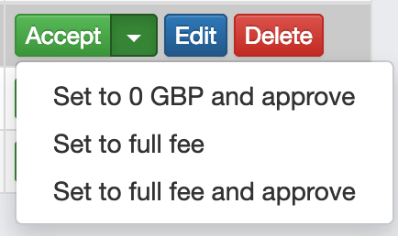

Add fixed discounts
Automatic discounts can be set up and will be updated by the system, such as Sibling discount, Multiple course discount, Max price discount, and Ensemble/Lesson discount. See more about discounts on the help forum.
If "Fixed discount" is being used, make sure to add these before posting! The fixed discount can be done at any time and will check for all payments that are eligible for the chosen discount.
It will not check and remove students that for some reason have lost their right to the fixed dixcount they had already received.
  - Go to Fixed discount Settings –> Discount -> Fixed discount (tab)
  - Fill out the fields accordingly.
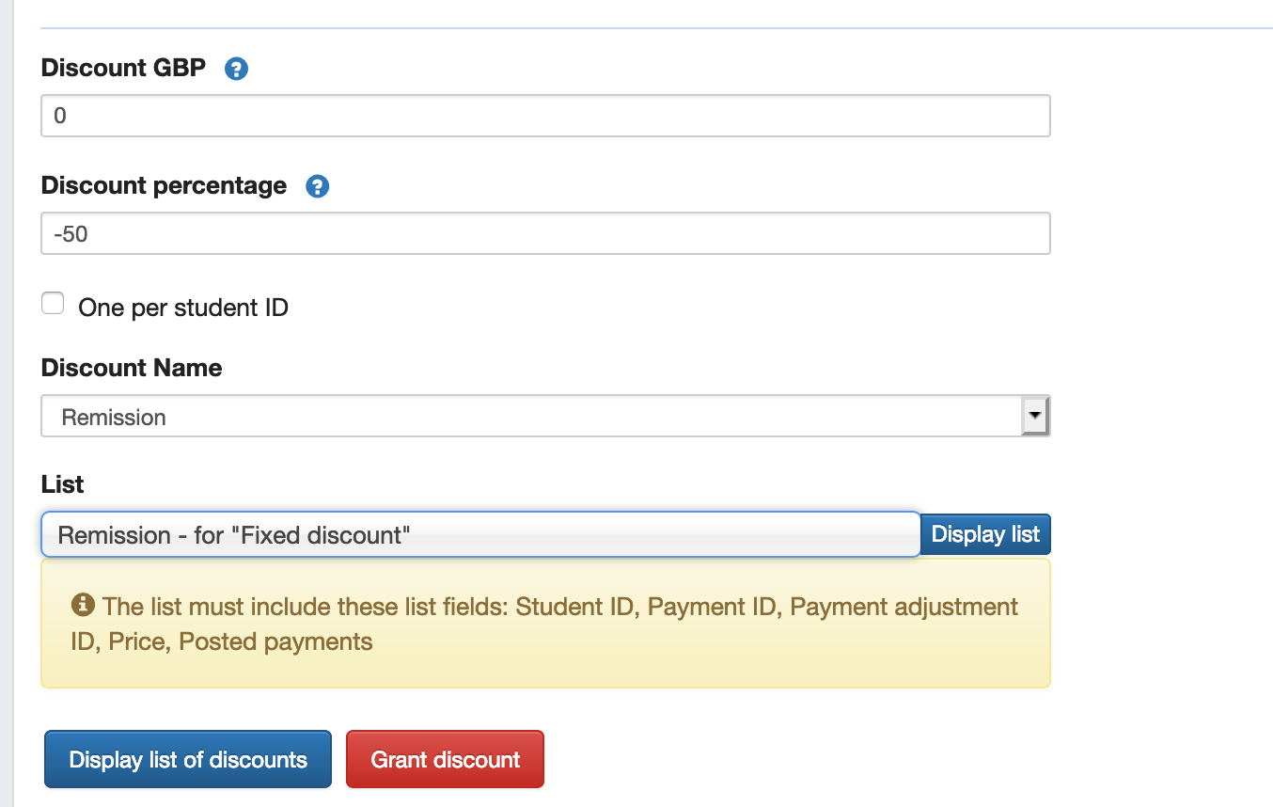
  - Press “Display list of discounts” – you now have a list of discounts that will be created if you grant it.
  - Press “Grant discount” to get the discount on the student’s payment.

Reimbursement
Create automatic reimbursement if you wish to do this on a regular basis. As a minimum, remember to make a refund before posting the final rate of the season, otherwise you must do it manually.

Do checks
Before posting, you should review the following if it is a larger posting:
Check for students under the age of 18 who are marked as payer for their activity or instrument hire.Lists –> Standard list -> "Check student payers"
To check if some student do not have any charge for a course use Lists –> Standard list -> "Pupil without charge".
If the setup is correct, all payments should be correct, but If you do wish to do checks you can use Lists. Either customize your own lists or you can find useful lists in List library -> Payments -> ex. * Payments per payer

Draft – Invoice – Post orders
Then you are ready to create your posting file:
- Finance -> Draft & postings - Create a new draft with optional comment box and correct fiscal year.
- Add Payments to the draft - Find the rate you want to post in the dropdown menu, and then press "Add all in the selected payment rate".
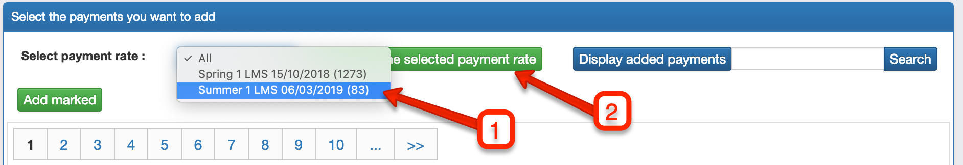
- Alternatively, select the students payments manually from the list, and press “Add Marked”. Then press "Add Marked”
- "Back to overview"
- You might need to check errors that are registred by the system before posting:
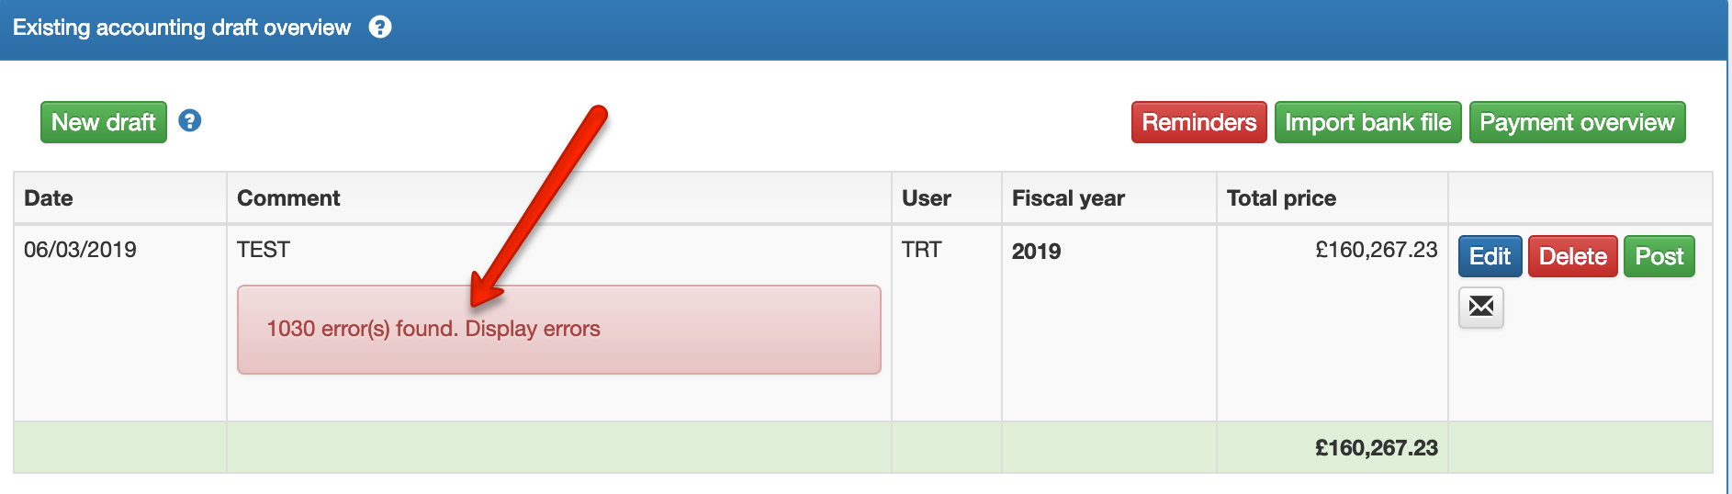
- Send invoice – press the envelop icon and choose your invoice template.
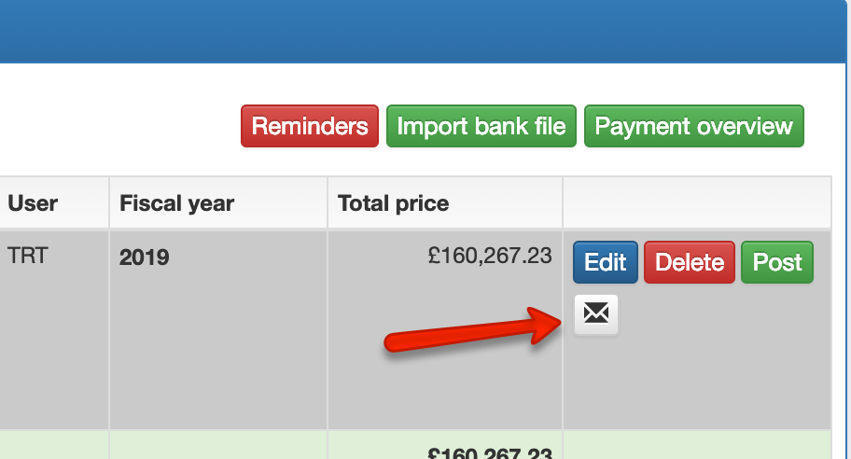
This email will only go out to the payer, and you can therefor use “Payer data” and “Accounting” merge fields:
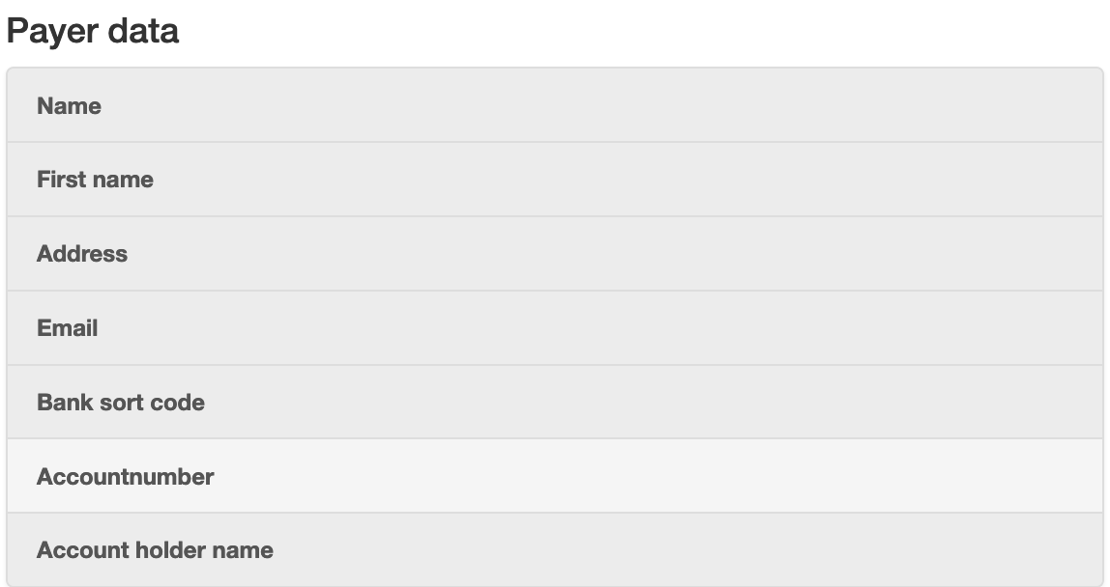
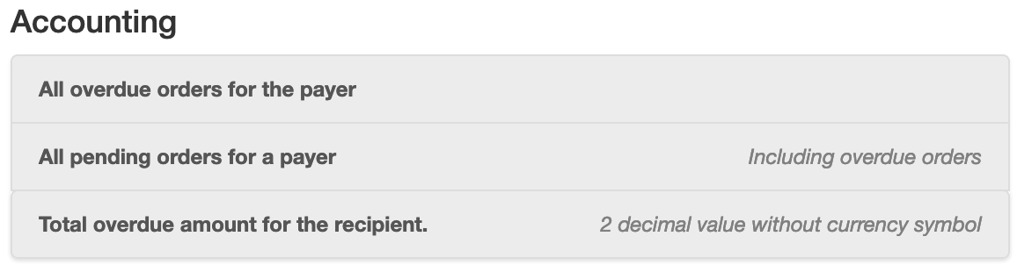
- Post – when invoice have been send of, press Post, and depending of your payment system setup, files will be ready to be downloaded or you can start taking in payments from credit card or other payment method.
- If file based, save the file to the folder path agreed with the municipality's finance office.

Direct Billing
For direct billing it is possible to filter out the payers with an active mandate, when you add payment to your draft:
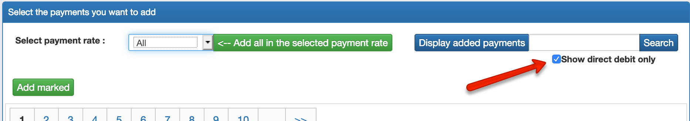

- Create the draft when you need to send out your DD schedule using the envelop icon (10 bank days before due date).
- DO NOT POST THE DRAFT YET
- You can still do amendments to the payment schedule.
- When direct debit file needs to be send of, check if there is any new DD-payments that have not been added to the draft (Add payments).
- Post the paymet, and you can now download your DD file for invoicing.
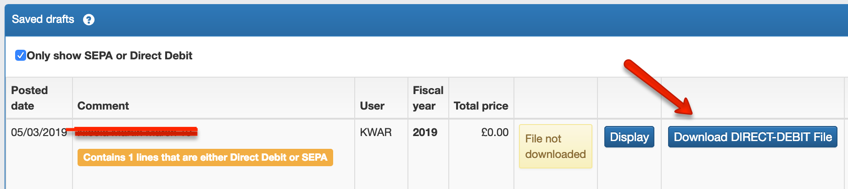

Payment will be marked as Direct Debit if the payer has an active mandate on the date the payment rate is due.
This can be viewed an edited on the Payers profile (not the student):

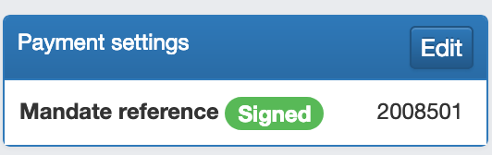

***

To setup and use Direct Debit contact Speedadmin Support.

Check and chase from Accounting

Accounting page Overview
All orders that have been posted (invoiced), and their corresponding payments can be seen on the Accounting page. All orders will have a payment status as:
- Pending (order have been posted but, not paid, but also not due yet)
- Paid (order have been settled)
- Overdue (order is due and have not been paid yet)
It is possible to filter on the Payment category, Rate, Payment status.

Be aware – to view all pages for your filter/search you can load them all in thebottom of the page – import when sending out messages!



A search function is available for Payer name.
To view Payers orders and payment press 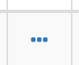 in the right-hand column. When expanded, it is possible to see payment status, full balance, overview of all orders and payments – press order or payment number to see details of these.
- Link to the payers profile.
 - Extract invoice as PDF

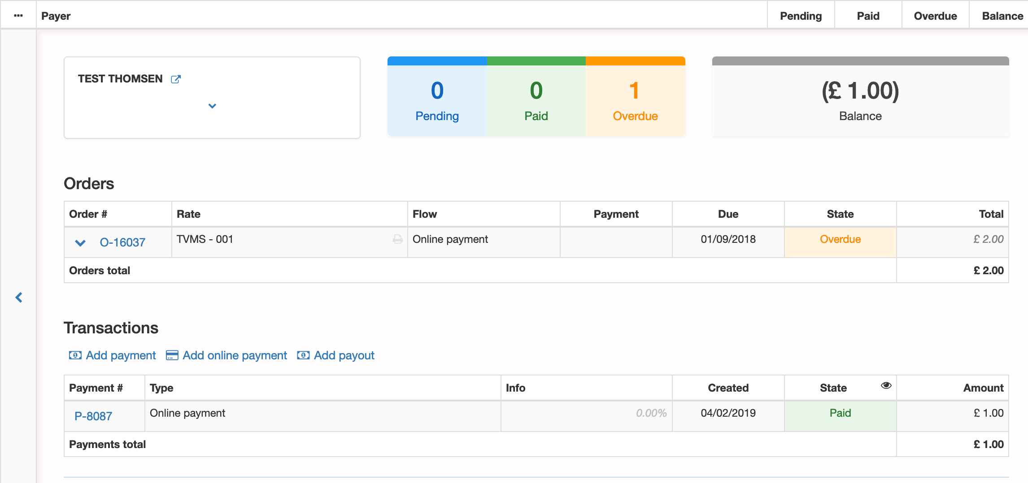
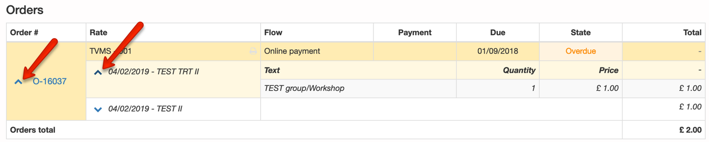

Add payments manually

To add payments that is not done by credit card or Direct debit follow this guide:
- Go to Accounting
- Search the payment/payer you want to add payments for:
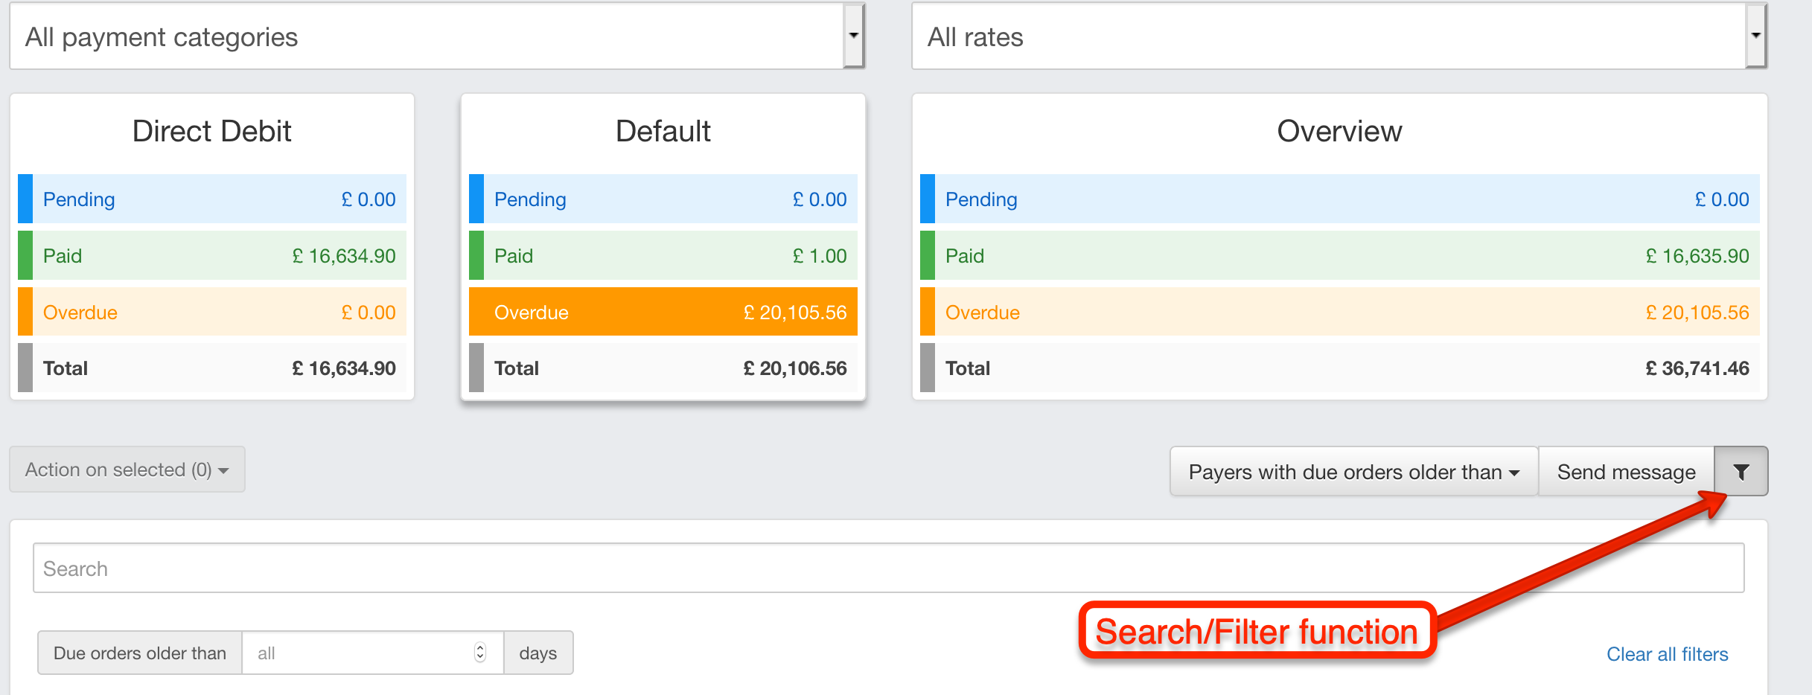

- Open the payment info for the payer and choose how you want to add payment:
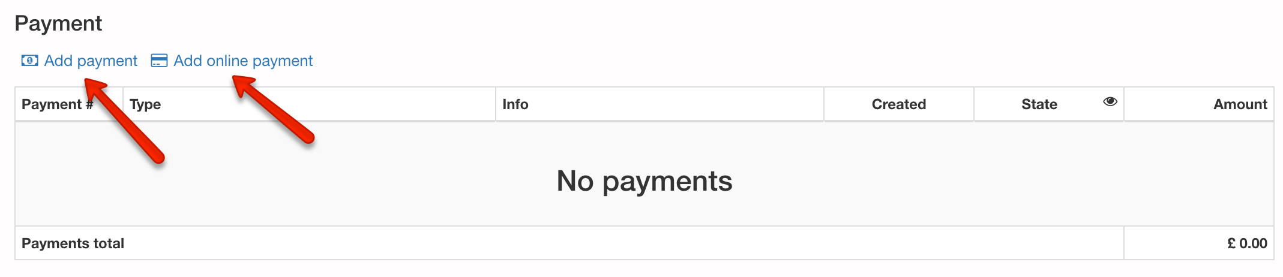
“Add payment” you can enter amount + method as Cash, Check or Bank transfer + a note for the payment:
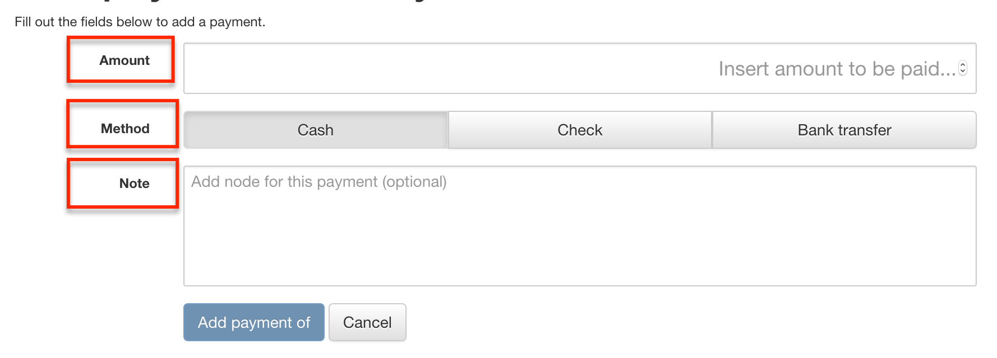
When entering the amount the system will notify how many orders will be covered.

“Add online payment” you will be transferred to the Secure Trading portal to enter Credit card type and details. (this can be use for taking payments over the phone).
- 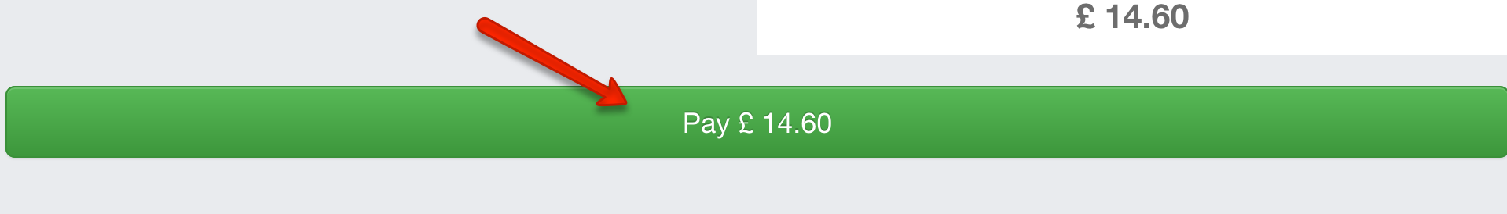

- 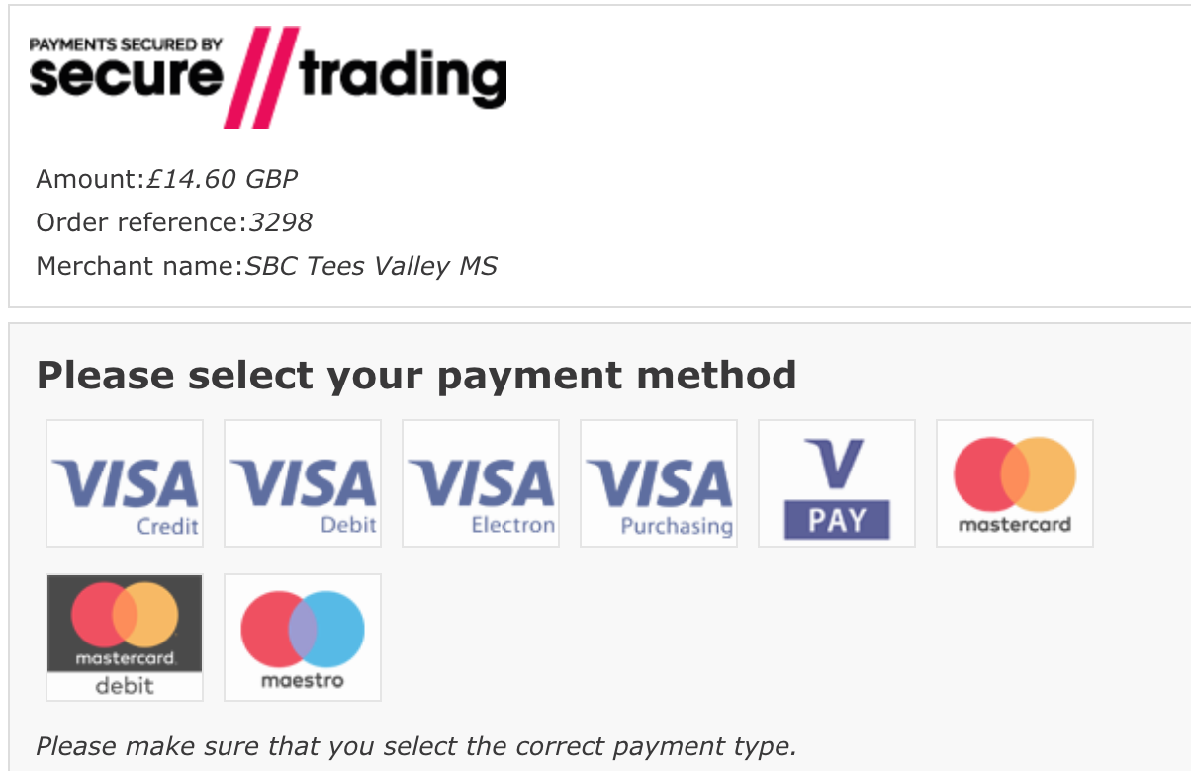

- 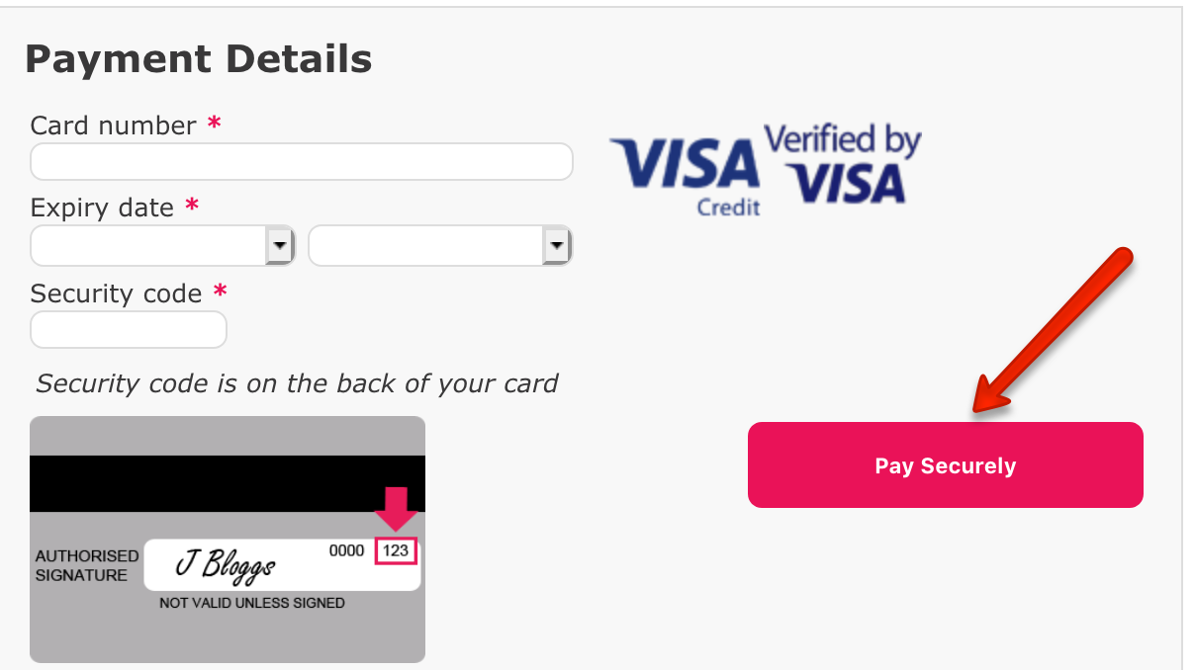

When payment covering a full order is added, the status will be changed to “Paid”.

Direct debit corrections

If Direct debit payment does not go through, you will need to correct the payment according to this guide:

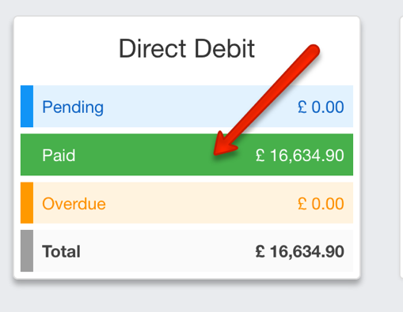
- Go to Accounting
- Choose “Paid” Direct Debit:

Or search the payer you need to correct.
- Open the payment info for the payer and choose Payment you want to decline:
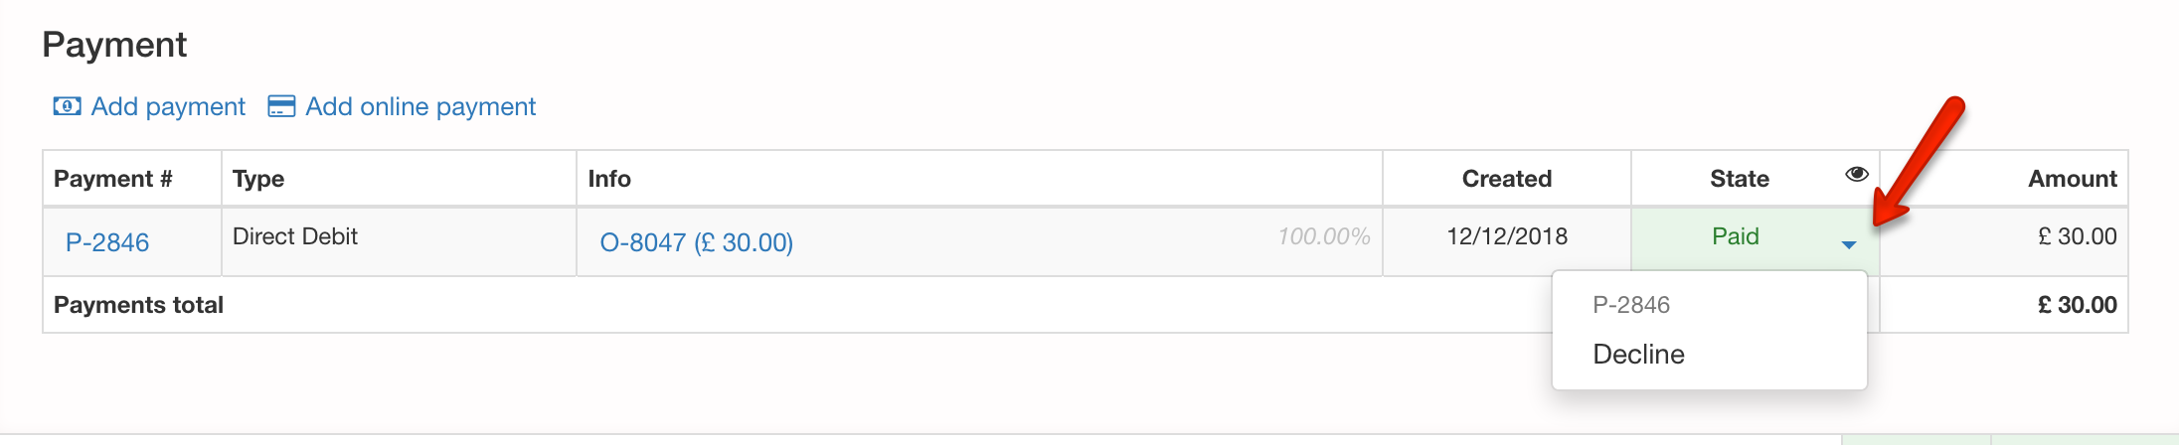
When choosing “Decline” you can add a reason:
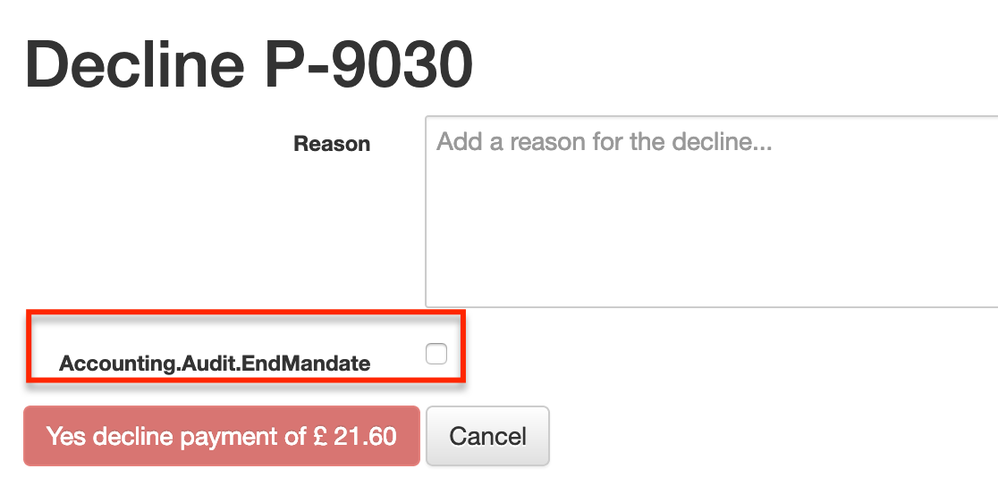
If you wish to end the mandate at the same time mark this in the tick box.

School billing

For now adding school invoices is done 100% manually according to this Step-by-step guide:

- Search the school you wish to add a payment for by using the “Super-searcher”, or Search > School
- On Schools profile choose the tab “Orders”
- Add orderline:

Date: Will always be controlled by the payment rate you choose
Comment: add info for what the order is for
Payment rate: Choose “Shool billing”, and the specific rate for when you want it to be due.
Price: Add the price for this payment

- Invoice will now be posted and send of along with the student invoices (Draft/Posting > Accounting)

Amendments can be done on payers profile (Reset)

If an already posted invoice needs to be amended, follow these steps:
- Student or Payers profile – Payment tab -> Press “Reset”: 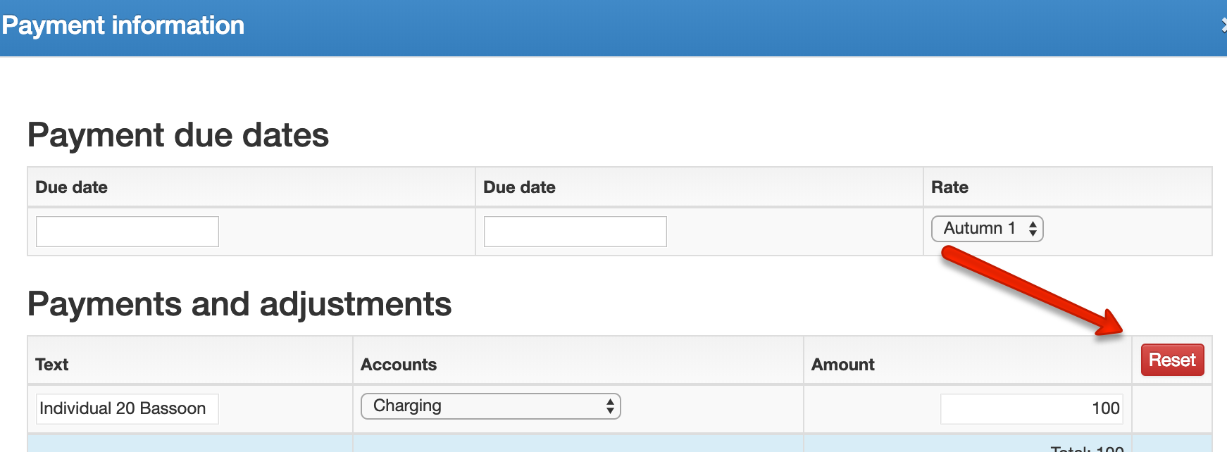

- You now have a new orderline with the minus on the amount charged.
You can edit the minus amount as you wish or create new orderline.

Post the payment and Accounting page will now be up to date.

If the wrong payer has been invoiced, you need to Reset/Credit the amount and post it.
Afterwards change the payer on the student profile.
  - Changing payer guardian – tab “Guardian” – State Payer:
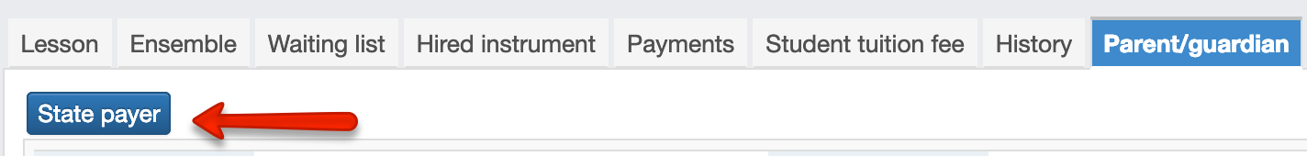

Tick the boxes to change all payments:
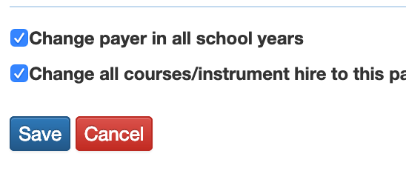

  - If changing the payer to a school or user, you will do this on the lesson and/or hire instrument by editing these on the student profile:
