Title: Event and Concert Planning | Category: 6. Activities / Booking
Last update: 06-01-2017 09:36 | Author: Krestina
Language: English | Keywords:

Event and concert planning

Create an event or a concert
The process for creating an event or a concert is the same, hence we will refer to the process jointly as “creating a concert”.
There are several ways to create a concert:
- SEARCH ROOM – click “display timetable” icon and create a booking on the desired day using the “create new booking” icon  . Finish by clicking “create new booking” at the bottom.
- START – ROOM OVERVIEW – find an available room and create the booking as described in bullet 1.
- Go to your own time table/a teacher’s time table and create a booking.
- START – CONCERT – CREATE.
For option 3 and 4, please remember to add a room to the booking subsequently!
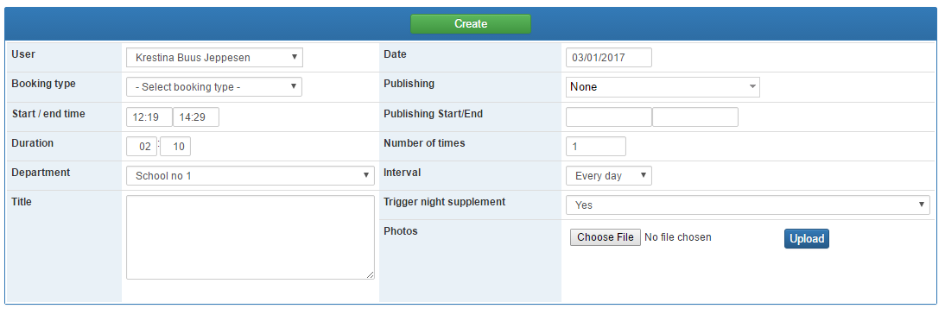
Fill in the form.
Duration – determines the total number of minutes that can be filled with music. When defining the duration, you hence need to allow time for introduction, switching between artists, applause etc.
A booking can be recurrent and the interval vary. You can add a photo or a file to the booking. Finally, you can choose to “publish” the event on different user groups’ start page.
Remember to add teacher, student and room (or any other resources you have defined) if they need to be booked together with the concert.

Allocating time slots to teachers
Every time you add a teacher so that they themselves can add students and music to the concert, you can allocate how much time each teacher can fill (1).
The total number of minutes will count down (2) in line with you allocating minutes to teachers.
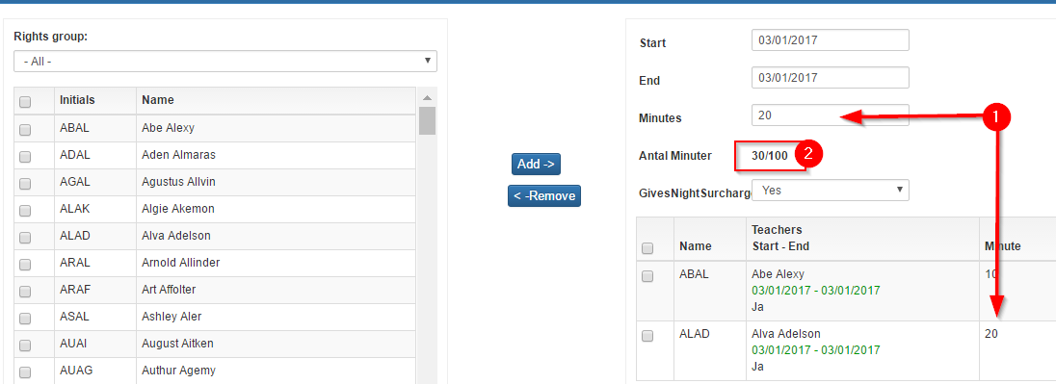

Adding students and music to the concert
In order to add content to the concert you need to click “edit concert” and “new concert piece”.
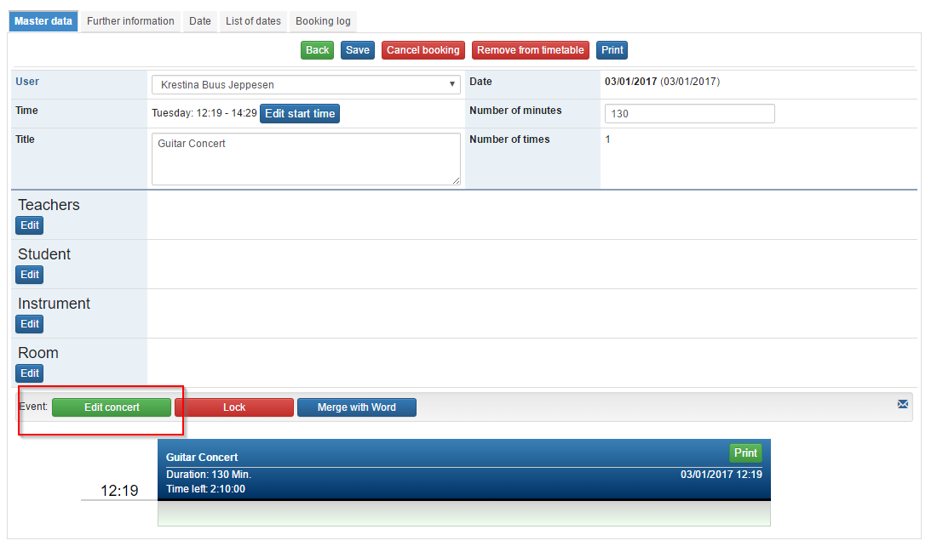

Here you can add artists and the music being played.
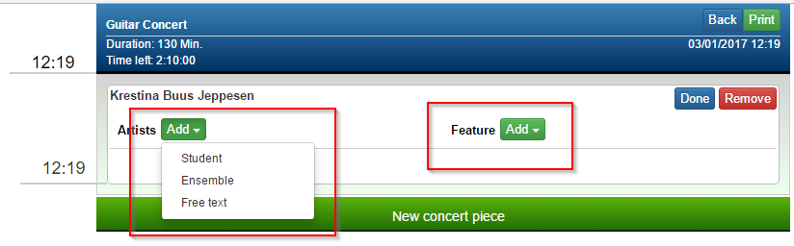
Artists – you can search and find ensembles or student(s) via free text, courses or “my students”. You can also type in a name yourself.
Feature – you can search and find a piece of music already registered in your system OR you can register a piece of music, which will then be in the system for future use.
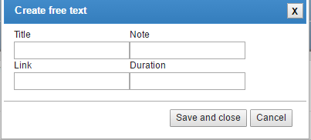
Best practice: Always try to search for the piece of music before typing it in via free text. This way you avoid the same piece of music being registered more than once with just small changes in spelling.
For all students, ensembles and music you add, there is a free text field, where you can add e.g. the instrument being played.
When your content is complete, click “back” in the top right corner and then “save”.
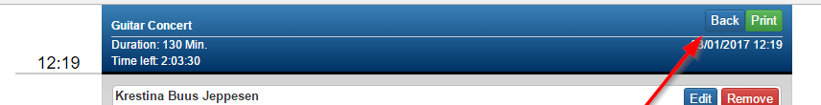

Editing the content of a concert
You can always go back and edit or remove any section of the concert.
For each section, you can also add students (if more students play the same piece) or add pieces of music (if one student play more than one piece)
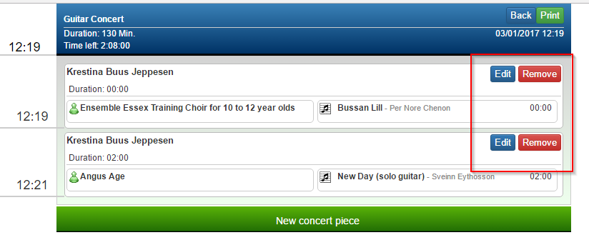

Managing the time of a concert
Every time you add a piece of music you can in the top left corner keep track of how much time is left compared to the “duration” that you defined when creating the concert.
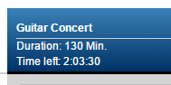

If you try to add music of more minutes than left, you will get the following warning:
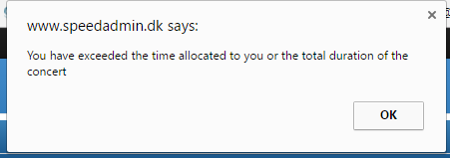

Editing the time and length of a concert
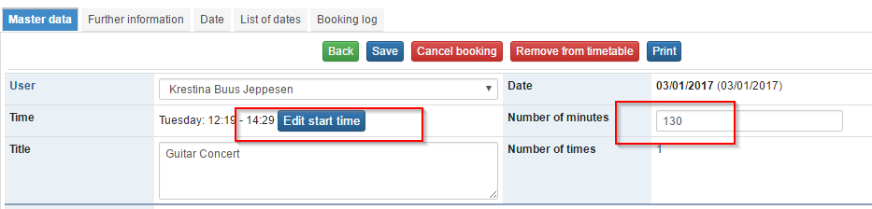
Editing the number of minutes – it is possible to edit the length i.e. number of minutes of the concert. This way the start time will remain the same.
Editing the start time – this takes you to the timetable where you can “drag and drop” the concert to the right time. Remember to “unlock” the timetable by clicking the red padlock 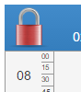 in the top left corner.
It is possible to adjust the time by minutes by using the arrows on the keyboard.

Administrative rights
The person who creates the concert, automatically becomes the administer of the concert, and only he/she can edit the length, start time etc.

“Locking” the concert
When the concert is fully planned, or completed you can lock it and thereby preventing further editing.
IF you need to unlock it anyway, only the administer of the concert can do so.
