Title: Activities and booking type | Category: 6. Activities / Booking
Last update: 05-01-2017 12:52 | Author: Krestina
Language: English | Keywords:

Activities and booking type

Activities with pre-defined fixed length
“Activity” is a tool to include tasks, which are not directly linked to teaching, in a teacher’s timetable and potentially their salary. These can be activities related to planning and running a concert, administration tasks, internal meetings, external cultural events etc.
“Activities” include events that trigger a compensation benefit as well as “activities” that don’t.
Go to SETTINGS – ACTIVITY and key in the name, number of minutes, lessons and type for each pre-defined activity.
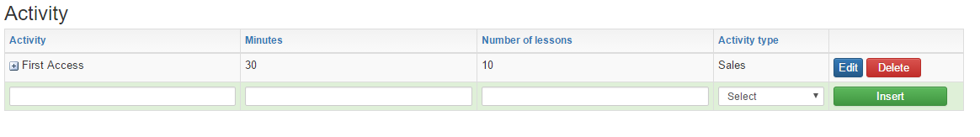
All definitions can be changed per teacher subsequently

Include activities in a teacher’s salary and timetable
In order to add activities to a teacher, go to LESSONS of the teacher, select the tab “Activities” and choose one of the pre-defined activities.
As you will see, the pre-defined data is automatically filled in but you can edit these.
Complete the task by deciding if the activity will trigger a compensation benefit i.e. be included in the teacher’s salary.
If you create an activity of 60 minutes x 3, this will show in the teacher’s timetable as a box of 60 minutes for three following weeks.
As is the case of ensembles, the first week you drag and drop the box, will become the starting week and the following two times will automatically appear in the timetable the following two weeks.
You can edit the dates but you cannot edit the length of the activity, it is 60 min. fixed

Activities with flexible duration
If you need maximum flexibility with regards to frequency and duration, you need to associate a “booking type” to the pre-defined “activity”.
This allows you to keep track of number of hours/minutes used out of a pre-defined pool of hours.
Go to SETTINGS – BOOKING TYPE
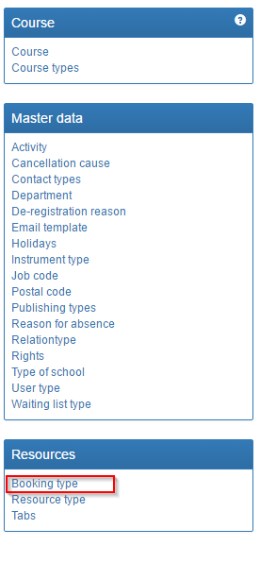
Create one or more booking types that are relevant for the activity. The name of the booking type is irrelevant as long as it is clear for the person doing the booking whether it triggers compensation benefits. The booking type can have the same name as the activity but this is not necessary.

You define the colour of the booking type by following the three steps marked by the numbered arrows below.

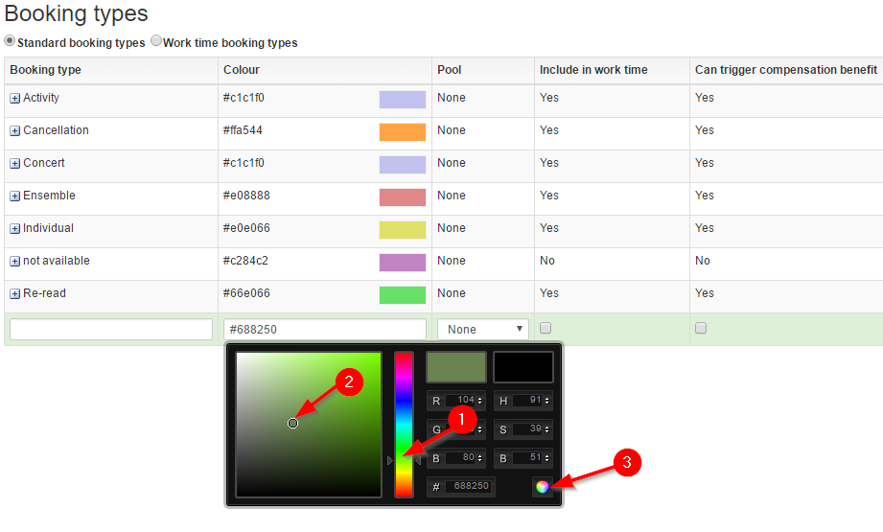

Once the booking type is created you can add the resource types you want to include e.g. student, teacher, room etc.

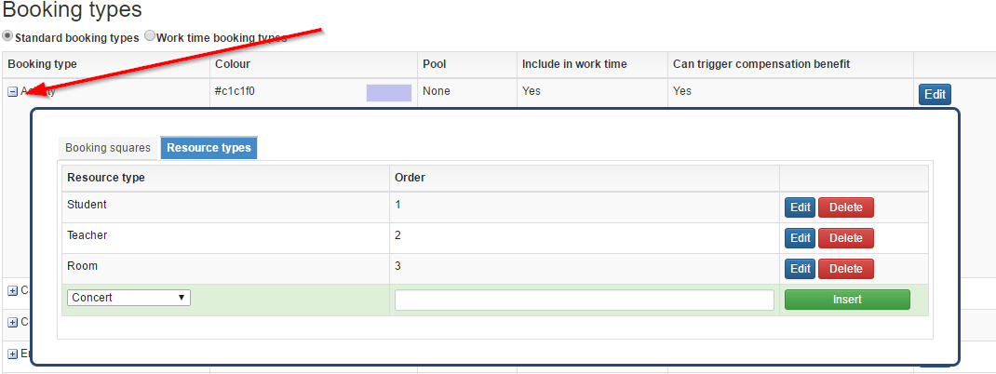

Got to SETTINGS – ACTIVITY and add the booking type to the desired “activity

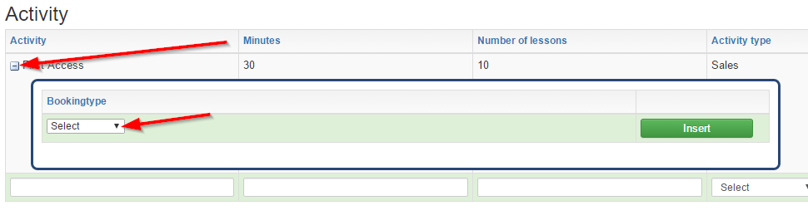

Include booking type in a teacher’s salary and timetable
Now you can add the activity to a teacher’s hour calculation with the total number of minutes in one pool.
On the teacher’s timetable you can make bookings of optional length, days and weeks by using the pin head .
When creating the booking, select the “booking type” you have added to the “activity” and give it a suitable title.
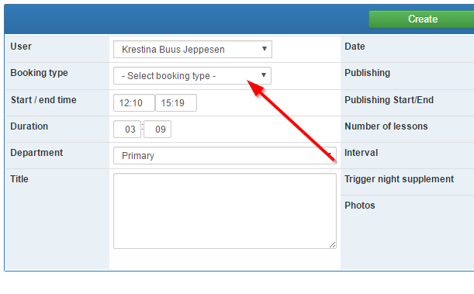
Now the booking will be in the teacher’s timetable and also in the teacher’s hour calculation with a countdown of the hours/minutes spent.
It is only possible to make one activity with the same booking type per teacher this way. This is due to the fact that the booking will count down on all activities, that the booking type is associated with.

